Person Centred Planning is a process of continual listening and learning.

It focuses on what is most important to the person now and in the future involving the people who know, love and care about them.

Person Centred Planning
5 Key Features

- The person is at the centre

- Family members and friends are partners in planning.

- The plan shows what is important to the person – now and for the future. It shows their strengths and what support they need.

- The plan helps the person to be a part of the community and helps the community to welcome them.

- The plan is ongoing. Everyone keeps on listening and learning to make things happen. The plan puts into action. The things the person wants to get out of life.

Person Centred Planning
has many tools

Some being:

MAP
(Making Action Plans)
Jack Pierpoint, Judith Snow, Marsha Forest and John O’Brien

PATH
(Planning alternative tomorrows with hope)
Jack Pierpoint, Marsha Forest and John O’Brien

ELP
(Essential Lifestyle Planning)
Michael Smull, Susan Burke Harrison and John O’Brien

Personal Futures
Beth Mount, Connie Lyle O’Brien and John O’Brien

MAP Making Action Plans

Developed by Judith Snow, Jack Pearpoint & Marsha Forest

Invites a person and a group of people who know, work with and like her/him, to map out where they need to go and what they need to do to improve the person’s life.
Group looks at the person’s history, dream and nightmares and adds their ideas.
Spend time listening to the things that best describe the person, his/her gifts, strengths and talents.
Thinks about the best way for the person to move towards the dreams and away from the night mares
Develops and action plan

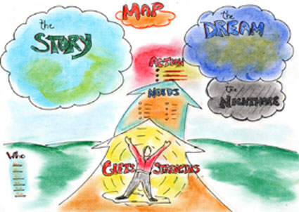

PATH Planning Alternative Tomorrows with Hope

Developed by Marsha Forest, Jack Pearpoint & John O’Brien

Involves a committed group of people and provides a focus on where they want to be heading

Looks at the “North Star” or dream for the person

Imagines possible and positive achievements over the next 1-2 years to define goals

Looks at “Now”

Identifies what the group needs to do to stay strong and enrols people who can help

Plans the steps needed to achieve goals

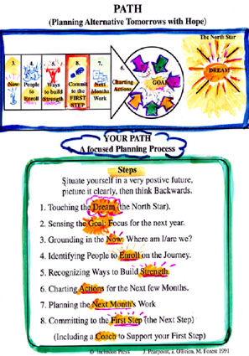

ELP Essential Lifestyle Planning

Developed by Michael Smull and Susan Burke Harrison

A very detailed planning style

Focuses on the individual’s life now and how that can be improves and/or maintained

Looks at what is important to the person and what support the person requires to these things present, or absent

Includes section on communication

A way of beginning to get to know a person and to build a team around the person

A good basis for Individual Service Design

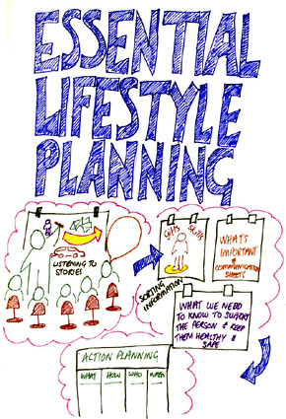

Personal Futures Planning

Developed by Beth Mount and John O’Brien

Spends time getting to know the person and what their life is like now

Records graphically the key areas of the person’s life, their history, places they use, relationships, preferences, dreams and hopes

Involves a group of people in developing ideas of how to make the person’s dream a reality, by building on opportunities and overcoming obstacles

Group members commit themselves to particular actions and set timescales

Action Plan

Will Happen
Who will do it?
When will it happen?
Review

